***Part 1a: Analyzing Custom Reports (40%)***

The core metrics custom report for the past 4 weeks prior to our survey launch date (January 25 - February 22) are included in Appendix A. The analyses below only include this date range as well. All of the data in the custom reports is filtered to include only hits from the NY Metro Area.

Because EatNomz is a new company and the date-range limits the size of the dataset, many of the auxiliary pages do not have enough visits to be significant in our analysis. Therefore, we will only examine the core pages of the website. When we look at the session data, only the home and product pages have a meaningful number of sessions. However, because we are looking at page-level data, the sessions data is only incremented when someone enters on that page, and is therefore skewed towards the home and product pages. Therefore, the sessions data is insufficient for our analysis and we have used Pageviews and Users most of our analyses as proxies of session data.

**Bounce Rates**

Because more than 83.11% of the site entrances are through the home page, and entrances from other pages are all under 10 entrances, the only relevant bounce rate in the custom report is that of the home page. The bounce rate of the home page is 41.84%, which is on par compare with the industrial benchmark. However, considering the fact that most visits to the website are through direct links (60.86%), and only 18.03% of the visitors come from organic search, we believe the home page bounce rate could be further reduced because direct links tend to drive lower bounce rate than average. This is because people who visit eatnomz.com through direct link are more likely to be famaliar with the product rather than complete strangers.

In eatnomz.com, pages that provides substantive information, such as FAQ (35.23%) and the Xiang Gu Ji Tang product page (33.33%) generally have a exit rate that is higher than other pages such as the collection page and cart page. Even though this behavior is expected due to the substantive nature of these web pages, we found the high exit rate in Xiang Gu Ji Tang product page to be particularly concerning. This is because Xiang Gu Ji Tang is in the purchasing funnel of eatnomz.com and high exit rate in this page will likely prevent a customer from being converted.

Upon further examination of the page, we have attributed the high exit rate partially to the design of the web page. As illustrated in figure 1, If a user were to enter the product page through the collection page, he would have received no new information regarding the product on the landing screen and have to scroll down for more product descriptions. Furthermore, the product description on the page is relatively unorganized and hard to read for visitors, providing frustration that is most likely the cause of exit. In comparison, as illustrated in figure 2, Amazon.com offers much more information on its product page at the landing screen with bullet points in the center offering more information about the product in an organized manner. Therefore, we recommend eatnomz.com adopt similar layout in order to decrease its product page exit rate.

We believe eatnomz.com’s exit rate could be further improved by making the “information pages” more interactive. Currently, out of five pages(excluding home page) with highest exit rate(FAQ, Xiang Gu Ji Tang, How Does Nomz Work, About Us, Blog), all except the Xiang Gu Ji Tang page contain large block of texts and no interactive elements. We believe that by adding interaction elements such as videos and replace text blocks with javascript elements, visitors will be more engaged on those pages and are less likely to exit.

**Unique Visitors**

The homepage is getting the most users (unique visitors) at 236 users, followed by the products page at 72 users. As stated previously, 13 pages have a user count of greater than 30, allowing us to analyze many sections of the website. Other pages of note with high user counts are the “about us,” “how nomz works,” “shopping cart,” FAQ, individual product pages, and checkout pages.

When examining eatnomz.com with secondary demension of user type, we have discovered that the About Us(54) and How Nomz Works(52) page have the highest unique new visitors while the collections(29) and cart page(28) have the highest unique return visitors. This observation validated our assumption that while new users explore the sites to learn more about the business, returning users simply clicks on the buy button and purchase the product. Therefore, we recommend Nomz focuses on making About Us and How Nomz Works page more appealing and interactive and focuses on making collection page and the cart more convenient and accessible when improving its web layouts. Measures to improve website attractability may include methods of improving website interactiveness such as adding videos, as mentioned above. Measures to improve convenience could include making Add To Cart option available directly on the product page.

Furthermore, we have also discovered a huge discrepancy among new visitors visiting the home page and other pages (210 vs ~50). Therefore, we have concluded that New Visitors are the main contributors to the home page’s high bounce rate. Combining with the discovery of the last paragraph, we believe eatnomz.com should priorizie making the website more interactive over making it more convient in order to reduce bounce rate.

**Highest and lowest average time per page**

Overall, individual product pages have the highest average time on page, followed by the home page. Visitors spend on average around 2 minutes on the home page, around 2.5 minutes for chicken soup and oxbone soup, and around 3 minutes on Vietnamese Pho soup. This is particularly auspicious because it means Vietnamese Pho Soup, a product Nomz has recently released, was gaining more traction than other products even before it was released.

We high time on page for pages that contains product information is a double edged sword. On one hand, it suggests that those contents are interesting to the users and they will spend more time on the page when there is content relevant to them (i.e. their receipt or a product they have sought out). However, it might also mean that the product descriptions are confusing that users have to spend longer than normal to understand the product provided. Therefore, we recommend eatnomz.com to provide a more structure layout for information on its product page to reduce unnecessary time on page while adding more interesting facts about its products (such as the story of creation of Pho) to increase productive time on page.

Compare to pages with product information displayed, pages with company information displayed, such as About Us, FAQ, and How Does Nomz Works, all have times on page that is lower or around 1 minutes. In particular, people on average only spend around 7 seconds on the Our Team page. This low average time measure suggests that users are less interested in learning about the company and are much more interested in the product. Therefore, we recommend Nomz to display more product related information throughout the website such as adding reviews snippets to the home page.

**Custom Reports**

From our custom reports we gained insights on demographics, visitor types (new vs. returning), and device category. Please refer to appendix B for more details.

With respect to demographics, 79% of users and 80% of new users are millennials (ages 25-34). This figure is reassuring, as it suggests that the customer base EatNomz was targeting in their business plan -- post-college, young professionals working in the city -- matches the customer base visiting their website. Additionally, because the customer base is so polarized, we will be able to narrow the target audience in our adwords campaigns.

With respect to visitor type, EatNomz’s website experiences a greater count of new users than returning users, with returning users accounting for 24% of all users, and new users accounting for 76%. Based on the large new user figure, we can conclude that EatNomz’s user base was rapidly expanding during this period of time.

A detailed comparison between New and Returning users revealed striking similarity between those two groups. Those two group of users share similar exit rate (~42%), bounce rate(~25%), and pages/session (~3.8). However, returning visitors spend much longer time browsing during their sessions (1.5 min difference), they also engage in three times as many sessions as new users (3.3 vs. 1). Finally, New users account for only $2.95 of revenue on average per user, while returning user account for $17.44 of revenue on average per user.

We believe this information is optimistic for eatnomz.com. This is because New Users exhibit almost exact same behavior as returning users, which means that eatnomz.com is currently appealing to the correct customer segment and they are very likely to return for another session as returning users and make purchases. However, we do encourage eatnomz.com to attract new visitors that is outside of the current customer segment group to further gain traction in the Great New York area. This could potentially be the subject of our Adword campaign.

With respect to device category, desktop accounts for the majority of sessions, users, and new users during the observed time period at 70%, 62%, and 63% respectively. This is followed by mobile, which has most of the remainder. Tablet, on the other hand, is insignificant during this time period.

When we compare desktop and mobile customers, we notice that desktop has a lower average time on page, higher pages/session, and lower bounce rates than mobile. Mobile, on the other hand, has a bounce rate of 66%, suggesting that mobile is much more likely to lead to a bounce. Additionally, during this time period, desktop accounts for 80% of revenue, making it the main revenue source at this point in time for device category. The superior performance of desktop suggests that the mobile experience is lacking in comparison to the desktop experience. If we take another look at their website on an iphone screen (the #1 mobile device for users visiting EatNomz), we see that, with the large font and most of the text below the fold, the webpage is not customized for mobile users. (Please see the last image in Appendix B for an image of the webpage on an iphone screen.) Although mobile devices experience less traffic than the desktop, mobile users still account for a significant amount of the user base. In order to cater to the busy users who want to order off of their phones, eatnomz.com will need to improve the usability of the mobile version in future iterations of the site, in order to improve the bounce rate for mobile devices.

**Key Metrics: Users, New Users, and Revenue**

Key metrics for EatNomz include users, new users, and revenue. We are only considering the NYC Metro area, and therefore have filtered our data to include only users in this location. Other geographic factors are not considered. In EatNomz’s business plan (cited in milestone 1), the primary goal of phase 1 (the current phase) is to grow the customer base in order to drive revenue upwards. If we look at appendix C, we see that there is a relationship between users and revenue, as they tend to move with one another.

Additionally, if look at the second image in Appendix C we see that the trend lines for users and new users closely fit together. Although the users figure will always greater than new users, we see that the two are very closely related. This indicates that, for this period of time, most of the movement for users is being driven by new users visiting the page. As time goes on and we look at data after the survey period, we expect that the number of returning users will increase and the trend lines for users and new users will not be as closely associated. If, on the other hand, these trend lines continue to move together, it might potentially create an issue. This co-movement could be the signal that a significant amount the new users that we are bringing in are not staying around long enough to become returning users.

We noticed several key trends that depend on the day of the week. For example, we noticed that the measurements for users and revenue frequently dip on the weekends. Because the business model caters for working millennials, we can infer that this dip is because the customer is not ordering on the weekend because they are not working and would prefer to eat at home, cook, or eat out. This finding suggests that, when we conduct our adwords campaign, we will want to focus our efforts on the weekdays, and not spend as much money on adwords on the weekend. We also noticed that bounce rates seem to spike on the weekends, while the users measurement significantly decreases on the weekend, as seen in Appendix C.

**Other Meaningful Findings**

Below are a series of observations and insights that are relevant, but do not fit to any of the key metrics outlined above:

* The iphone is the mobile device with the most sessions at 147 sessions. All other mobile devices are below 10 sessions. This suggests that we should optimize mobile for iphones.
* 645 sessions come from a mozilla compatible agent, 451 from chrome, and 157 from saffari. Online forums suggest that views from mozilla compatible agents could come from “bots” and therefore are not as insightful. Therefore, we will need to perform additional research to determine if these views are from non-users, and, until then, optimize for chrome.
* 49% of sessions come from a windows computer, and only 14% from a mac computer. Windows computers had a lower bounce rate than mac computers, at 34% for windows and 41% for macs. This suggest that our users are mostly windows users, and we should therefore cater our website towards windows computers.

**Appendices:**

**Appendix A:**

A1: Sorted by sessions

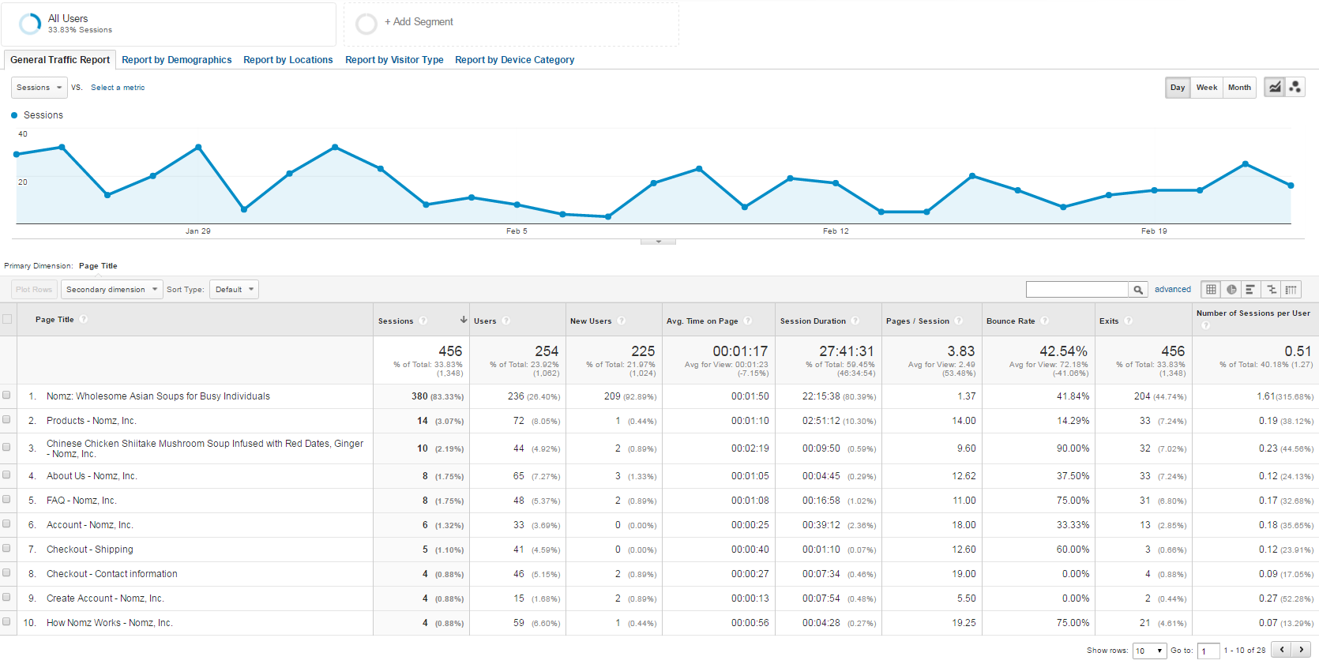

A2: Sorted by users (unique visitors)

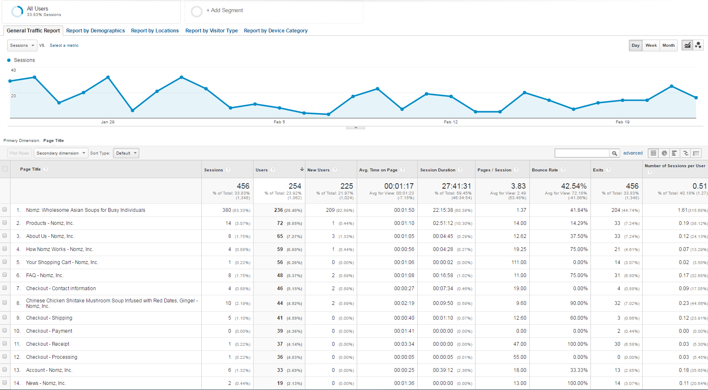

A3: Contribution of users to bounces

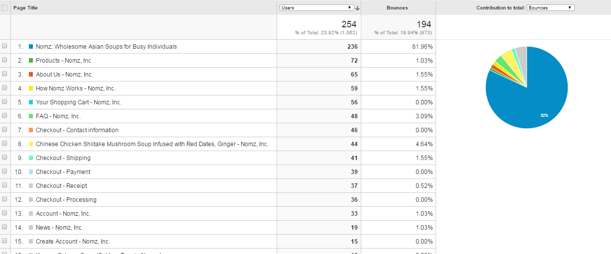

A4: Exits by page

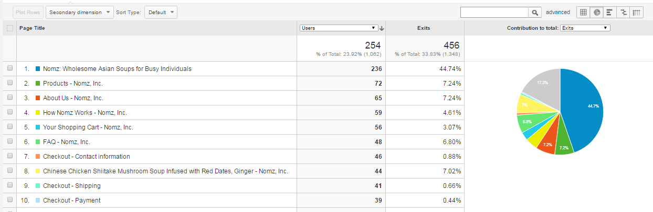

**Appendix B:**

B1: Demographics:

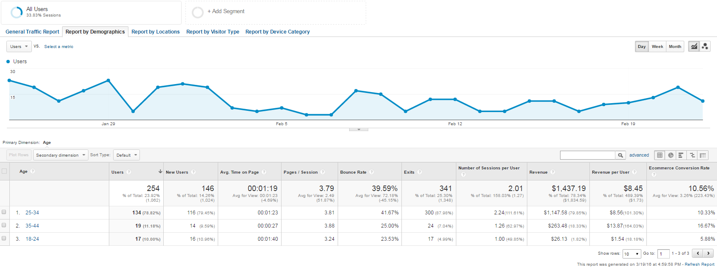

B2: Visitor Type:

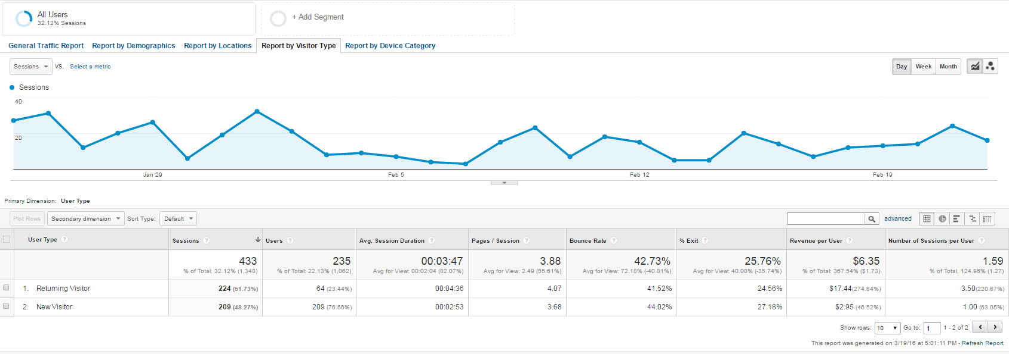

B3: Device Category:

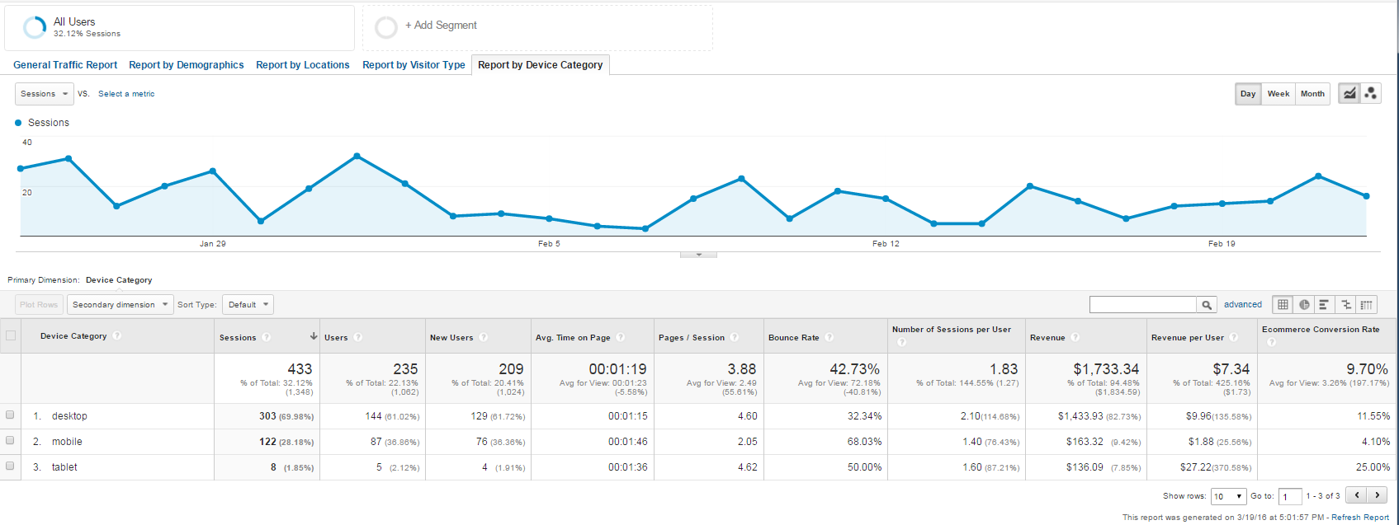

B4: Webpage on iPhone:

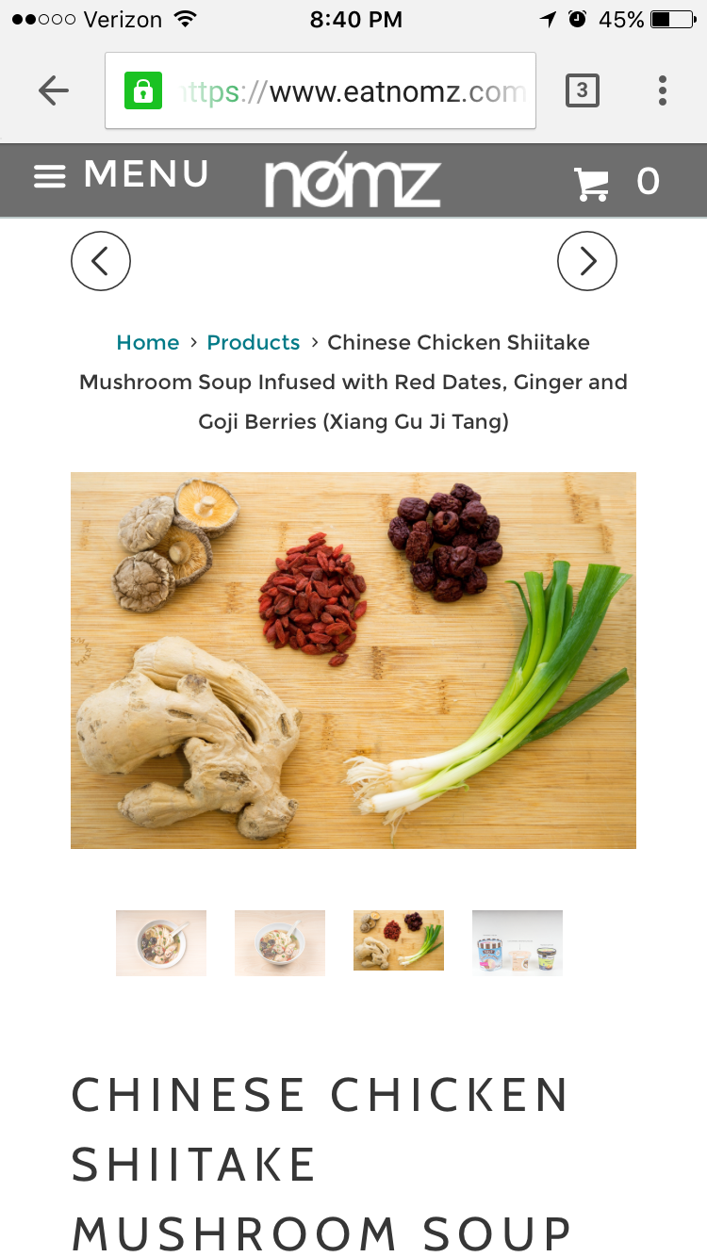

**Appendix C:**

Users & Rev:

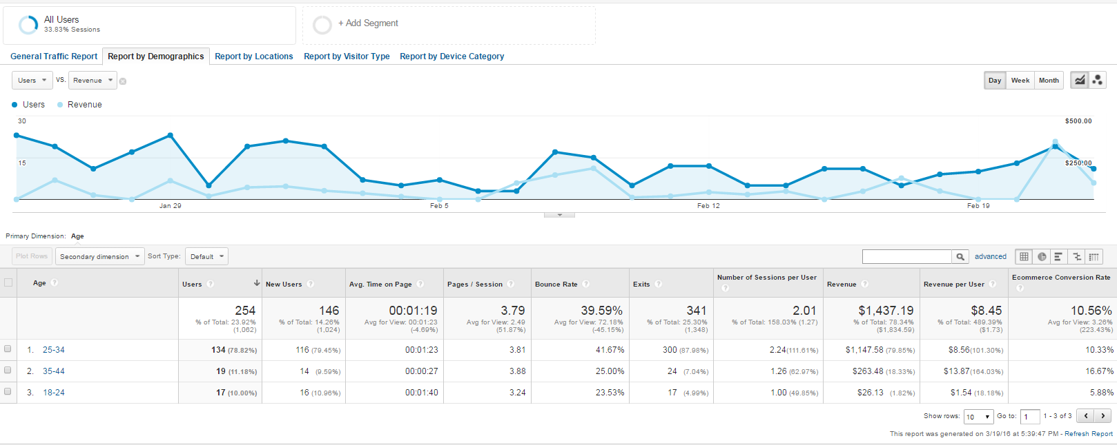

Users & New Users

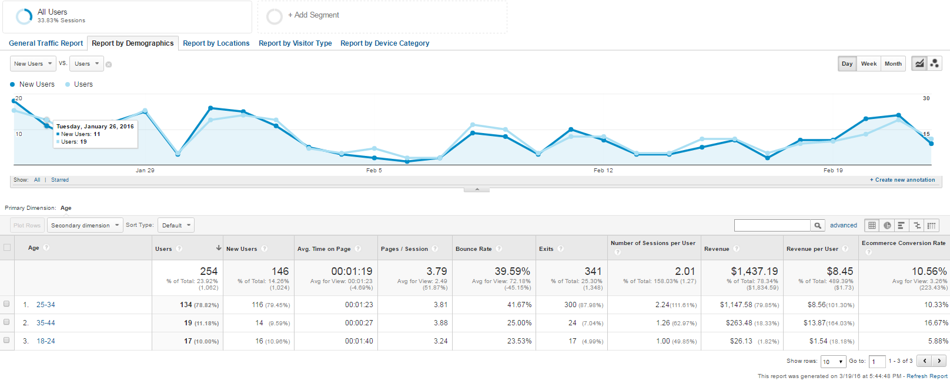

Users & Bounce Rates

